## Querying the rate of reaction of Magnesium with Hydrochloric Acid

**Rationale**

A chemical reaction is the process in which elements, the reactants, react with other elements to produce products (ref). Chemical reactions differ from physical reactions as they form a new substance and are near impossible to reverse, whilst physical changes do not change the reactants at an atomic level and can be reversed (ref). An example of a chemical reaction is the process of baking a cake, once the reaction is complete (the cake is cooked), the reactants (the ingredients) cannot be removed, as it is impossible to un-bake a cake. An example of a physical change is salt and water, they can be combined into a solution, and then separated (through distillation) into their separate respective forms, without ever changing their atomic molecular structure (ref).

For a reaction to occur an activation energy (AE) must be met, this is the minimum amount of energy required to break the existing bonds and for the reactants to form new ones, and thus creating the products. The rate at which these bonds are broken and created forms the concept of a reaction rate, or simply, the rate of a reaction.

The rate of a reaction is affected by four main factors: Temperature, Surface area, catalyst and concentration. These factors' effect varies depending on the physical state of the reactants, as another factor; pressure, affects the reaction rate of gas reactants. The individual way each factor affects the rate of a reaction is different, but fundamentally the same, this is because of the collision theory.

Collision theory forms on the basis of particles from both reactants mixing and reacting with each other. An increase in temperature (Thermal energy) increases the movement of the particles, thus a higher chance of the reactants' particles colliding and reacting. Similarly, an increase in the concentration of the reactants creates a higher number of particles in the same area, thus creating a higher chance of the particles colliding. A catalyst works by reducing the amount of energy needed to break and reform the bonds, thus creating a higher frequency of successful reactions from collisions. Lastly, surface area affects the rate of a reaction by exposing more of the reacting particles to each other, thus creating a higher chance of the particles colliding.

As stated above, reactions require energy for the breaking and formation of new bonds, this data is displayed in an energy profile diagram. Chemical reactions are either exothermic or endothermic. In an endothermic reaction, energy is absorbed, this means the energy left after the reaction is higher than the energy at the beginning. The absorption of energy reduces the thermal energy, creating a reduction in temperature. In an exothermic reaction, energy is released. This means the energy left is lower than the energy at the beginning. The release of energy increases thermal energy, creating an increase in temperature.

In this experiment, an exothermic single displacement reaction occurred between magnesium and hydrochloric acid to create magnesium chloride and hydrogen gas. The gas produced was measured every 5 seconds.

The balanced chemical equation for this reaction is:

$$Mg+2HCl→{MgCl}_{2}+H_{2}$$

Throughout this experiment, the chosen variable to be further explored was the concentration of hydrochloric acid. A relevant research question was developed to further explore how differing molarity affects the rate of this reaction.

**Research Question**

How does increasing the molarity of Hydrochloric acid by 0.5 increments from 0.5 to 3.0 affect the rate of reaction with magnesium and the amount of hydrogen gas produced?

**Methodology**

For the purpose of this experiment, the original method (Appendix A) has been modified.

**Modifications to Method**

|  |  |  |
| --- | --- | --- |
| **Original Method** | **Modification** | **Justification** |
| Only 2 Molar HCl was used | Concentration of HCl (0.5, 1.0, 1.5, 2.0, 2.5, 3.0) | To determine how the change in concentration affects the rate of the reaction, a range of different concentrations were used. |
| Volume of gas produced was recorded when the reaction ended | Record gas volume produced every 5 seconds | To more accurately record the curve/change along the reaction |
| 2 trials of the same molar HCl | 3 Trials instead of 2 | This increases the available raw data, allowing for the detection of outliers, and creating more accurate averages. |
| Only 3mL of HCL was used | 40mL HCL | To ensure there is enough reactant to complete the reaction without hindering the reaction. |

**Hazard Management**

|  |  |  |  |
| --- | --- | --- | --- |
| Hazard | | Management | |
| Risk | Risk Level | Prevention | Treatment |
| Irritation from hydrochloric acid | Medium | Eye protection, aprons, avoid skin contact, and wearing appropriate PPE. | Rinse effected area with cool running water. |
| Broken Glassware | High | Handle glassware appropriately. | Alert others of breakage, and seek medical attention immediately. (Use glass bin for disposal) |
| Spilt hydrochloric acid | Low | Pour acid over sink, and handle containers safely and slowly. | Removed spilt acid appropriately, ensuring to dilute. |
| Bruises from tripping | Low | Ensure workspace is clean and well managed, wear appropriate footwear in in science lab. | First aid kit and Safety Ice. |

**Environmental:**

Glassware was used in case there was a breakage, this ensures that the damaged equipment can be recycled appropriately and not contribute to landfill and other environmental damage. When disposing of hydrochloric acid, it was ensured that it was safely and appropriately diluted to an acceptable level that won’t affect animals or the surrounding environment, contributing to further degradation of the environment. It was also ensured that the amount of each molar acid required was calculated beforehand, preventing wastage of unused acid.

**Results**

**Figure 1: (Raw data of hydrogen gas created by Magnesium and HCl reaction; recorded every 5 seconds until)**



**Processed Data**

**Figure 2: (Figure 1 results averaged for each mole)**

**Figure 3: (Rate of reaction)**



**Figure 4: (Total gas produced by each Mole of HCl)**



**Figure 5: (Maximum uncertainty for each Mole)**



**Calculation Table**

|  |  |
| --- | --- |
| Formula | Sample |
| Average gas produced (5s intervals) (T being ‘trial’) $$\frac{T1+T2+T3}{3}=AVG Gas Produced$$ | (1 Mole @ 10 Seconds) $$\frac{5+4+3}{3}=4$$ |
| Reaction rate for each trial $$Rate=\frac{Tot. Gas Produced}{Tot. Time Taken}.$$ | (Reaction rate of 3 Mole) $$1.75= \frac{35}{20}$$ |
| Absolute uncertainty $$±\frac{Max-Min}{2}$$ | (For 0.5 Mole @ 180 Seconds) $$\frac{10-9}{2}= ±0.5$$ |
| Relative uncertainty $$\frac{Absolute error}{Avg time Per concentration*100\%}$$ |  |

**Analysis**

**Figure 6: (Rate of reaction Graph) (**Error bars are there)**

It is clearly displayed in Figure 6 that there is a direct correlation between an increase in hydrochloric acid molarity and the rate of reaction with magnesium. The general overall trend is a strong positive linear trend. This data shows that the rate of reaction benefits from a higher acid molarity as explained in the rationale. The data in Figure 6 is sourced from Figure 3 which states that 0.5 mole HCl produced hydrogen gas at a rate of 0.05 mL per second. Whilst 3 Mole HCl produced hydrogen gas at a rate of 1.75 mL per second, which is 35 times more than 0.5 Moles.

From the data in Figure 5, a linear trendline was selected for the graph in Figure 6. A linear trendline was selected as it best represented the trend of the data producing the highest R2 value of 0.951. An R2 value represents how well a data model fits the chosen trendline, with the best possible result being 1, and the lowest possible result being 0. An R2 value of 0.951 is very good as it conveys that the data very highly fits the selected trend.

An important figure to discuss in regard to experiments is the uncertainty in the trials. The uncertainty is the max value minus the smallest value in each trial divided by two. This allows for the calculation of the deviation/difference in records of the same test. The smaller the uncertainty value the greater the accuracy in the recording process, as theoretically, all trials should yield the same result, thus the larger the uncertainty value the greater the inaccuracies throughout the experiment. In all experiments, there will be natural and impossible to avoid inaccuracies, thus a small amount is acceptable. As shown in Figure 5, the uncertainty values range from 0-2 which is generally quite good. 3 Molar is a perfect example of having no deviation, with all records for all 3 trials having the same value, this is displayed in the raw data in Figure 1. The uncertainty values for 0.5 Moles and 2.5 Moles, 1 is an acceptable level. The uncertainty values for 1.5 Moles and 2 Moles are less favourable but are acceptable for this experiment. Lastly, the uncertainty value for 1 Mole is quite undesirable. For the purpose and nature of this experiment, this result is understandable.

*(Data Extrapolation Paragraph)­­*

*(Compare to other experiments)*

**Evaluation**

In this experiment, there were minimal inaccuracies throughout the recording process creating a reliable data set. The data is reliable and accurate as the uncertainty value as explained above is generally low, meaning there was great accuracy during the recording process. The reliability of the data is reinforced through the high R2 and the intricate care taken while conducting the experiment. The reliability can be assessed by the management of controlled variables such as the amount of HCl, size of the magnesium strip, and the usage of the same data scribe throughout all trials.

**Improvements**

While this experiment generated accurate data, there is always room for improvement. The largest cause for error within any data set is human error. There is room for error when transcribing values from the gas syringe. This is evident as the gas syringe has labels for 20, 40, 60 ml etcetera, whilst only having line markers for multiples of 5. During high molar fast reactions, the lack of labels can cause momentary confusion for the scribe. The values, therefore, are the scribe's interpretation within the moment. The reaction time of the scribe from when the timer reaches a 5-second interval until they read the gas syringe and write the data can cause inconsistent records. The use of a computerised or digitalised gas syringe with a digital display is highly recommended as it eliminates the scribe's time to interpret the analogue readings on the gas syringe, thus reducing the delay, and furthermore the inconsistencies. For even further improvements, a fully computerised recording system could be implemented. This would automatically record the exact volume produced at the most precise and correct time, eliminating the possibility of human error within the recording process.

Further simple improvements would be to increase the number of trials completed for each Mole. This allows for a greater data set, allowing for easier detection and elimination of outliers.

Lastly, a simple but major improvement could be implemented to increase the overall reliability of the dataset. Allowing more time for the experiment would allow more precise measurements and readings, preventing any inaccurate rushed sample sets.

**Extensions**

An extension for this experiment would be to increase the range of HCl used. Using stronger moles of HCl will allow for a more accurate data set to graph the trendline on, confirming it is still a linear trend. If stronger Moles were to be used, it would also be beneficial to decrease the intervals between the data records from 5 seconds down to 1. This would ensure the is still an appropriate number of data/ entries being collected for each trial, allowing for a reliable uncertainty value and percentage to be calculated.

**Conclusion**

In conclusion, it is found that increasing the concentration of HCl by 0.5 increments creates a positive linear trend on the rate of reaction. Thus, the rate at which hydrogen gas is produced by an HCl and magnesium single replacement reaction is directly proportionate to the molar HCl within the reaction.

**References**

BYJU'S. (2023). When magnesium and hydrochloric acid react, they produce. Byjus.com. <https://byjus.com/question-answer/when-magnesium-and-hydrochloric-acid-react-they-produce>

Energy Profile: Definition, Diagram, Reaction | StudySmarter. (n.d.). StudySmarter UK. <https://www.studysmarter.co.uk/explanations/chemistry/kinetics/energy-profile/>

Kotz, J. C., & Treichel, P. M. (2018). Chemical Reaction. In Encyclopædia Britannica. Britannica. <https://www.britannica.com/science/chemical-reaction>

Laidler, K. (2022). Reaction Rate. In Encyclopedia Britannica. <https://www.britannica.com/science/reaction-rate>

Labster Theory. (2020, December 1). Exothermic and endothermic reactions - Labster Theory. Theory.labster.com. <https://theory.labster.com/exothermic-endothermic/>

Macgillivray, J. (2023, August 21). Discord DM (R. Hampson, Interviewer) [Review of Discord DM]. <https://www.discord.com>

National Geographic Society. (2023, January 25). Changes in Matter: Physical vs. Chemical Changes | National Geographic Society. Education.nationalgeographic.org. <https://education.nationalgeographic.org/resource/changes-matter-physical-vs-chemical-changes/>

Taylor, S. (2020, May 17). R-Squared. Corporate Finance Institute. <https://corporatefinanceinstitute.com/resources/data-science/r-squared/>

**Appendix**

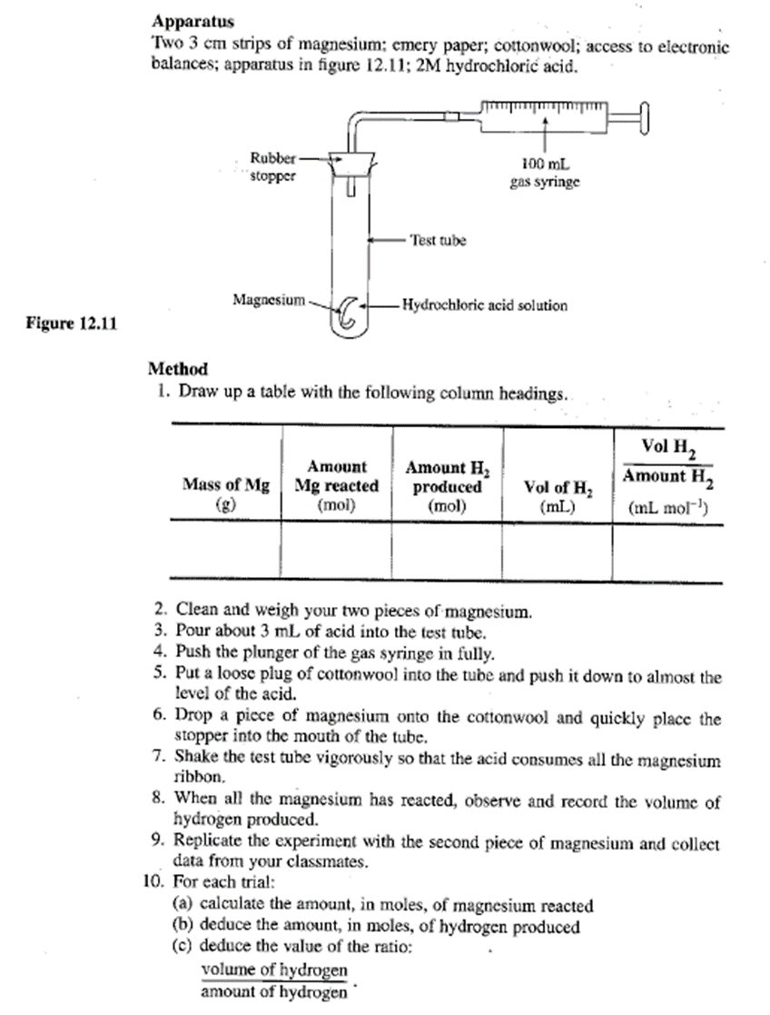**Figure A: (Original Method)**

**Figure B: (Figure 1 graphed)**